EMOTION-BASED CHAT-BOT

A MINOR PROJECT-I
Submitted in Partial Fulfillment of the Requirement for the Award of the Degree of

BACHELOR OF TECHNOLOGY
IN
COMPUTER SCIENCE & ENGINEERING

SUBMITTED TO


Rajiv Gandhi Proudyogiki Vishwavidyalaya, Bhopal (M.P.)

SUBMITTED BY
SAKSHAT SHRIVATRA (0176CS231173), PRANJAL CHANSAURIYA (0176CS243D11), YASH RAJ VISHWAKARMA (0176CS231231), RAKESH KUMAR (0176CS243D14)
Lakshmi Narain College of Technology Excellence, Bhopal (M.P.), India

UNDER THE SUPERVISION OF

Miss. Muskan Shrivastav
Department of Computer Science & Engineering
Lakshmi Narain College of Technology Excellence, Bhopal (M.P.), India



Department of Computer Science & Engineering
Lakshmi Narain College of Technology Excellence, Bhopal (M.P.)
Dec- 2025

CANDIDATE’S DECLARATION
We, SAKSHAT SHRIVATRA, PRANJAL CHANSAURIYA, YASHRAJ VISHWAKARMA, RAKESH KUMAR, student of Bachelor of Technology, Computer Science & Engineering, Lakshmi Narain College of Technology Excellence, Bhopal hereby declare that the work presented in the project entitled “Emotion-based chatbot” is outcome of my own bona-fide work, which is correct to the best of my knowledge and this work has been carried out taking care of Engineering Ethics. The work presented does not infringe any previous work and has not been submitted to any University for the award of any degree / diploma.

The project entitled “Emotion-based chatbot” being submitted by “SAKSHAT SHRIVATRA” (Roll No.:174), “PRANJAL CHANSAURIYA” (Roll No.:240), “YASH RAJ VISHWAKARMA” (Roll No.:227), “RAKESH KUMAR” (Roll No.:244) has been examined by us and is hereby approved for the award of degree “Bachelor of Technology in Computer Science & Engineering”, for which it has been submitted. It is understood that by this approval the undersigned do not necessarily endorse or approve any statement made, opinion expressed or conclusion drawn therein, but approve the project only for the purpose for which it has been submitted.

Student name: Sakshat Shrivatra
Enrollment No.: 0176CS231173

Student name: Pranjal Chansauriya
Enrollment No.: 0176CS243D11

Student name: Yash raj Vishwakarma
Enrollment No.: 0176CS231231

Student name: Rakesh Kumar
Enrollment No.: 0176CS243D14

CERTIFICATE
This is to certify that the project entitled “Real-time Chat Application” is the bona-fide work carried out independently by SAKSAHT SHRIVATRA , PRANJAL CHANSAURIYA , YASH RAJ VISHWAKARMA , RAKESH KUMAR student of Bachelor of Technology, Department of Computer Science & Engineering from Rajiv Gandhi Proudyogiki Vishwavidyalaya, Bhopal. In the partial fulfillment of the requirement for the award of the degree of Bachelor of Technology, and this project has not formed previously the basis for the award of any degree, diploma, associate ship, fellowship or any other similar title according to our knowledge.

SUPERVISED BY:

Miss. Muskan Shrivastav
Department of CSE
LNCTE, Bhopal

FORWARDED BY:

Prof. (Dr.) Megha Kamble
(Head, Department of CSE)
LNCTE, Bhopal

APPROVED BY:

Dr. Anil Kumar Saxena
Principal
LNCTE, Bhopal

ACKNOWLEDGEMENT

At the outset, we would like to link to thank the Almighty who made all the things possible. Writing this project report would not have been possible without the support of several people whom we need to wholeheartedly thank. A special thanks to “Dr. Megha Kamble” Professor and Head, Department of Computer Science and Engineering, LNCTE, Bhopal who helped us in completing the project and exchanged her interesting ideas thoughts and made this project easy accurate.

We are equally grateful to Dr. Anil Kumar Saxena, Principal, LNCTE for providing all the necessary resources to carry out this project work. We would like to thank all staff members of CSE, L.N.C.T.E. and friends, for their moral and psychological support.

Sakshat Shrivatra (176CS231173)
Pranjal Chansauriya (176CS243D11)
Yash raj Vishwakarma (176CS231231)
Rakesh Kumar (176CS243D14)

CONTENT

Title Page no.

Abstract

Chapter 1 Introduction.................................................................................................

1.1 Motivation......................................................................................……………
1.2 Scope....................................................................................................................
1.3 Objective..............................................................................................................
1.4 Application…………………………………………….......................................

Chapter 2 Literature Survey........................................................................................

2.1 Literature Survey………………………………………………………………..
2.2 Conclusion………………………………………………………………………

Chapter 3 Problem Statement......................................................................................
3.1 Problem Statement

Chapter 4 Minimum Hardware and Software Requirements..........................

4.1 Software Requirement…………..………………………………………………
4.2 Hardware Requirement…

Chapter 5 Methodology Used.............................................................................

5.1 Method…………………………………………………………………………

Chapter 6 Design Framework…………………..........................................................

6.1 ER Diagram……………………………………………………………………..
6.2 Use Case Diagram……………………………………………………………....
6.3 Data Flow Diagram…………………………………………………….……….

Chapter 7 Implementation……….…………….......................................................

6.1 Snapshot
6.2 Coding…………………………………………………………………………..

Chapter8 Testing…...……………………….………….…………….........................
8.1 Testing

Chapter 9 Conclusion & Future Scope ………...........................

Conclusion & Future Scope

References

CHAPTER 1
INTRODUCTION

In an era where technology is becoming increasingly empathetic, our project introduces a next-generation emotion-based Ai Chatbot designed to understand, respond, and adapt to human feelings. Rather than simply exchanging messages, this intelligent system interprets emotional cues to deliver meaningful, personalized interactions. With a strong emphasis on user experience, accuracy, and adaptability, our chatbot transcends traditional conversational tools by creating a space where users feel heard, understood, and supported. Step into the future of digital communication — where emotions guide the conversation and every response is crafted with empathy.
In essence, our emotion-driven chatbot represents the perfect fusion of advanced AI models and an intuitive, user-centric interface. Join us as we explore how emotional intelligence, natural language processing, and thoughtful design come together to create interactions that go beyond words — offering a truly engaging, supportive, and human-like conversational experience.

1.1 MOTIVATION

The motivation behind our emotion-based chatbot project arises from the growing need for digital interactions that go beyond simple text exchange. In today’s fast-paced world, users expect technology not only to communicate but also to understand them. Traditional chat systems often lack emotional awareness, leaving conversations feeling mechanical and disconnected. Our project aims to overcome these limitations by developing an intelligent, emotion-responsive chatbot capable of interpreting user sentiment and delivering empathetic, context-aware responses. By integrating emotional intelligence into conversational technology, we strive to create a platform that enhances user connection, supports mental well-being, and offers a more human-like communication experience. Through this initiative, we hope to contribute to the evolution of emotionally-aware AI systems and redefine how individuals interact with digital platforms across various domains

1.2 SCOPE

The scope of our emotion-based chatbot project encompasses the development of an intelligent, adaptable, and user-centric conversational platform capable of understanding and responding to human emotions. Designed to serve a wide spectrum of users — including individuals seeking support, businesses aiming to enhance customer engagement, and communities focused on interactive communication — the chatbot will offer emotionally-aware conversations, sentiment analysis, personalized responses, and adaptive interaction flows. Additional features will include secure user authentication, tailored conversation settings, and cross-device accessibility to ensure a seamless and consistent experience. Our project aims to deliver a responsive system that not only communicates but connects, offering meaningful interactions across various domains.
1.3 OBJECTIVE
The objectives of our emotion-based chatbot project are designed to address essential user needs and ensure the development of an intelligent, empathetic, and responsive communication system. These goals guide the entire development process and establish clear criteria for project success.
Project Objectives:
- Create an Emotion-Aware User Experience:
• Develop an intuitive and interactive interface capable of understanding user emotions and delivering empathetic responses.
- Ensure Data Security and Privacy:
• Implement strong security protocols to protect user conversations, emotional data, and personal information.
- Enhance Emotional Communication Efficiency:
• Integrate features such as sentiment analysis, adaptive responses, and instant emotional feedback to improve the quality of interaction.
- Scalability and High Performance:
• Design the system to efficiently handle a growing user base while maintaining fast, accurate emotional interpretation and response generation.
- Adaptability and Personalization:
• Enable customization of chatbot behavior, tone, and interaction style to match individual user preferences and emotional needs.

  - APPLICATION

  - Emotional Support and Team Well-Being:
• Enhance internal communication by allowing team members to express concerns, stress levels, or feedback through an emotion-aware chatbot.
• Streamline discussions and decision-making by offering emotionally contextual insights that improve team understanding and collaboration.
  - Emotion-Driven Customer Support:
• Provide businesses with a platform that delivers empathetic, real-time customer assistance based on detected user emotions.
• Improve customer engagement by offering personalized, sentiment-aware responses that address issues more effectively.
  - E-commerce Emotional Assistance:
• Enable emotionally intelligent interactions between customers and support systems during their shopping journey.
• Enhance the shopping experience by recognizing customer frustration, confusion, or satisfaction and responding appropriately.
  - Emotion-Aware Educational Interaction:
• Facilitate meaningful communication between students and educators by identifying emotions such as confusion or stress.
• Support collaborative learning by offering immediate, empathetic feedback and promoting emotional well-being in virtual classrooms.
  - Emotion-Guided Project Collaboration:
• Improve teamwork by detecting emotional tones within project discussions and helping maintain healthy communication dynamics.
• Support real-time collaboration on tasks, documents, and updates with insights that foster a positive and productive work environment.

CHAPTER 2
LITERATURE SURVEY

2.1 LITERATURE SURVEY
- Introduction to Emotion-Aware Communication
• Explore the concept of emotionally intelligent communication in digital systems.
• Discuss the evolution of chatbots from rule-based text responders to emotion-sensitive conversational agents.
- Existing Emotion-Based and AI Chatbot Technologies
• Review popular AI-driven conversational systems such as Replika, Woebot, and Google’s Dialogflow.
• Analyze their features, emotional intelligence capabilities, response generation, and interaction design.
- Technological Frameworks for Emotion Detection and Response
• Investigate commonly used frameworks for developing emotion-responsive chatbots (e.g., NLP models, sentiment analysis engines, machine learning pipelines).
• Compare different approaches, their accuracy, adaptability, and integration complexity.
- Security and Privacy in Emotion-Aware Chatbots
• Examine the security practices used to protect sensitive emotional and conversational data.
• Discuss encryption, secure authentication, ethical data handling, and user privacy considerations in emotion-driven systems.
- User Interface Design for Emotion-Based Chatbots
• Explore effective UI/UX principles for emotion-centric chatbot interfaces.
• Highlight the importance of empathetic design, visual cues, and user-friendly interaction flows.
- Mobile Application Development for Emotion-Aware Systems
• Investigate best practices for implementing emotion-based chatbots on mobile platforms.
• Discuss challenges such as resource limitations, latency, and emotion detection accuracy on mobile devices.
- Emotion-Aware Tools in Collaboration and Workspaces
• Explore how emotion-sensitive chatbot features support team communication and workplace well-being.
• Discuss the impact on collaboration quality, conflict reduction, and team productivity.
- Emotion Recognition in Healthcare Communication
• Examine the role of emotionally intelligent chatbots in telemedicine, mental health support, and patient monitoring.
• Highlight privacy, security, and ethical considerations in handling emotional health data.
- Chatbots in Educational Environments
• Review emotion-aware chatbot usage in online learning platforms for improving engagement and support.
• Explore their contribution to student motivation, personalized feedback, and emotional well-being.
- Emotion-Driven Interaction in Social Platforms
• Investigate how social networking platforms incorporate emotional intelligence into communication tools.
• Discuss the impact on user engagement, digital well-being, and online social behavior.
- Emotion-Aware Interaction in Gaming
• Explore how emotional feedback improves in-game communication and player experience.
• Discuss challenges in emotion detection within dynamic gaming environments.
- Emotion Recognition in IoT and Smart Devices
• Examine the integration of emotion-aware communication in IoT applications.
• Discuss how emotional insights enhance device interaction, personalization, and remote support.
- Challenges in Emotion-Based Chatbot Development
• Identify common challenges such as accurate emotion detection, bias, contextual understanding, and personalization.
• Discuss existing solutions, ethical frameworks, and best practices to overcome these challenges.
- Future Trends in Emotion-Aware Communication
• Explore emerging trends such as multimodal emotion recognition, affective computing, and human-AI empathy models.
• Discuss potential advancements and their implications for next-generation chatbot development.
- Conclusion of Literature Survey
• Summarize key insights from existing research in emotion-aware chatbot technologies.
• Identify research gaps such as deeper emotional context understanding, culturally adaptive responses, and long-term emotional engagement — which the current project aims to address.

2.2 CONCLUSION
In conclusion, this literature survey has provided a comprehensive understanding of the current landscape of emotion-aware chatbot technologies. By examining existing emotionally intelligent systems, sentiment analysis models, ethical considerations, and UI/UX design principles, the review highlights the rapid advancements shaping this emerging field of affective computing.
The study of popular emotion-based and AI-driven chatbots such as Replika, Woebot, and other conversational agents revealed a wide spectrum of emotional detection capabilities, interaction styles, and underlying technologies. Each system adopts a unique combination of NLP models, machine learning frameworks, and user experience strategies, emphasizing the importance of selecting the appropriate architecture for building an effective emotion-responsive chatbot.
Security and privacy surfaced as critical areas of focus, particularly due to the sensitivity of emotional and psychological user data. Robust encryption, secure authentication, ethical data handling, and transparency are essential for fostering user trust and ensuring regulatory compliance in emotionally intelligent communication systems.
The review of user interface and experience design further emphasized the need for empathy-centered interfaces that facilitate comfortable, supportive, and engaging interactions. Insights from mobile and cross-platform development highlighted the importance of responsiveness, accessibility, and consistent emotional interpretation across devices.
Additionally, the integration of emotion-aware chatbot features across healthcare, education, workplace collaboration, gaming, and IoT applications demonstrated the transformative potential of emotionally intelligent communication. These systems can enhance mental well-being, improve engagement, personalize support, and strengthen user satisfaction across diverse domains.
As technology continues to evolve, future trends such as multimodal emotion recognition, deep affective computing, and increasingly human-like conversational models will shape the next generation of emotion-aware systems. This literature survey provides the foundation for the present project, identifying key research gaps—such as deeper contextual emotional understanding, cultural adaptability, and long-term emotional consistency—that must be addressed to build a meaningful, effective, and innovative emotion-based chatbot capable of redefining digital communication.

CHAPTER 3
PROBLEM STATEMENT

3.1 PROBLEM STATEMENT
Existing emotion-based chatbot systems face significant challenges related to accurate emotion detection, user personalization, data security, and adaptability across different domains. Many current solutions struggle to interpret complex emotional expressions, provide context-aware responses, or maintain consistent emotional intelligence during extended interactions. Additionally, concerns surrounding the handling of sensitive emotional data pose risks to user privacy and trust. These limitations reduce the effectiveness of emotionally intelligent communication and hinder seamless integration with diverse platforms and use cases.
This project aims to overcome these issues by developing a robust, adaptive, and secure emotion-aware chatbot capable of accurately detecting user emotions, generating empathetic responses, and offering a customizable interaction experience. The system will emphasize enhanced emotional accuracy, strong security measures, and flexible integration to support a wide range of environments, ultimately improving the quality and authenticity of digital emotional communication.

CHAPTER 4
Minimum Hardware And Software Requirements

4.1 SOFTWARE REQUIREMENT
- Server-Side Requirements:
1. Operating System:
  - Windows (X64) for production environment
2. Web Server:
  - Chrome or Microsoft edge for serving static files and acting as a reverse proxy
3.Programming Language:
  - Python for Backend application logic
4. Web Framework:
  - Html , CSS , JS for building the API
5. Real-Time Communication Framework:
  - Use WebSockets with Flask-SocketIO to implement a real-time communication framework.
6. Database:
  - Kaggle dataset
7. Authentication:
  - JWT AUTH 2.0 Authentication for user authentication

- Client-Side Requirements:
1. Web Browser
  - Support for modern web browsers (Chrome, Firefox, Safari, Edge)
2. Front-end Framework:
  - Html , CSS , JS for building the user interface
3. HTML, CSS, JavaScript
  - Use HTML for structure, CSS for styling, and JavaScript for dynamic behavior
4. Development Tools:
1. Integrated Development Environment (IDE):
  - Visual Studio Code or any IDE suitable for JavaScript development
2. Version Control:
  - Git for version control

- Security Tools:
1. SSL/TLS Certificate
  - Enable HTTPS using SSL/TLS certificates for secure communication
2. Authentication and Authorization
  - Implement JWT AUTH 2.0 Authentication for secure user authentication.

- Deployment Tools:
- Backend Deployment Platform:
- Heroku for deploying and hosting the Node.js/Express.js backend
- Utilize Heroku CLI for seamless deployment.

- Frontend Deployment Platform:
- Netlify for deploying and hosting the React.js frontend.
- Leverage Netlify CLI for simplified deployment processes.

4.2 HARDWARE REQUIREMENT
- Multi-core processor : A dual-core or quad-core processor is recommended to efficiently manage real-time chatbot responses, emotion detection operations, and background processes.
- At least 2GB of RAM At least 2GB of RAM is required for smooth execution of the chatbot system. More RAM may be needed depending on the size of the model, UI animations, and the number of concurrent users.
- Adequate storage space : Sufficient storage is required for the HEAL TALK application files,AI model dependencies, and user interaction logs.
An SSD is highly recommended to improve the application's loading speed and overall performance.

CHAPTER 5
METHODOLOGY USED
I. Agile Methodology
Description:
Agile is an iterative and flexible software development methodology that focuses on continuous improvement, teamwork, and rapid adaptation to change. For a dynamic system like HEAL TALK, where emotional detection patterns and user interaction behavior constantly evolve, Agile ensures smooth and progressive enhancements throughout the development cycle.
Application to HEAL TALK – Emotion-Based Chatbot:
Agile is perfectly suited for the development of HEAL TALK, as the chatbot relies heavily on emotional understanding, user feedback, and real-time interaction data. Using Agile, the team can:
- Continuously refine emotion-recognition accuracy based on user responses.
- Update and train the AI model frequently with new emotional datasets.
- Make rapid adjustments to conversational flows and empathy-based responses.
- Incorporate user feedback during each sprint to improve trust, usability, and emotional relevance.
- Iteratively enhance features like sentiment analysis, voice tone detection (if applicable), and personalized health suggestions.
Agile enables HEAL TALK to evolve naturally with user needs, ensuring the chatbot becomes more emotionally intelligent and user-friendly over time.

II. Scrum
Description:
Scrum is a structured framework under the Agile methodology that divides the development process into short, time-boxed cycles known as sprints. Each sprint aims to deliver a functional and testable component of the system. For a chatbot like HEAL TALK, these components may include emotion-recognition modules, NLP-based conversation improvements, backend logic, and UI/UX updates.
Application to HEAL TALK – Emotion-Based Chatbot:
Scrum is highly effective for building HEAL TALK because the chatbot’s emotional understanding and user interaction patterns evolve continuously. Using Scrum allows the team to:
- Focus on delivering small, working increments such as improved sentiment analysis models or new emotional response categories.
- Adapt quickly based on user testing and emotional accuracy feedback.
- Improve conversational flow, detection accuracy, and personalized health responses with each sprint.
- Conduct regular Scrum ceremonies—sprint planning, daily stand-ups, sprint reviews, and retrospectives—to identify gaps, improve emotional interpretation logic, and enhance overall performance.
Scrum ensures that HEAL TALK grows with each iteration, becoming more emotionally aware, intelligent, and user-friendly over time.

III. Waterfall
Description:
The Waterfall model is a traditional, linear software development approach in which each phase—such as requirement analysis, system design, implementation, testing, and deployment—is completed sequentially. Progress flows in one direction, making this model suitable for components with clearly defined and stable requirements.
Application to HEAL TALK – Emotion-Based Chatbot:
While Waterfall is not ideal for highly adaptive AI features, it can still be effectively applied to certain stable and well-structured parts of the HEAL TALK system. For example:
- Designing the UI layout for the chatbot platform.
- Setting up the database structure for storing user interactions, logs, and health-related data.
- Implementing non-AI functional modules that have fixed behavior and do not require continuous emotional updates.
- Creating documentation, static pages, or backend utilities that do not change frequently.
Waterfall helps establish a clear and well-organized foundation for these components, ensuring that the non-AI sections of HEAL TALK remain consistent, reliable, and well-documented.

CHAPTER 6. DESIGN FRAMEWORK
6.1USE DIAGRAM 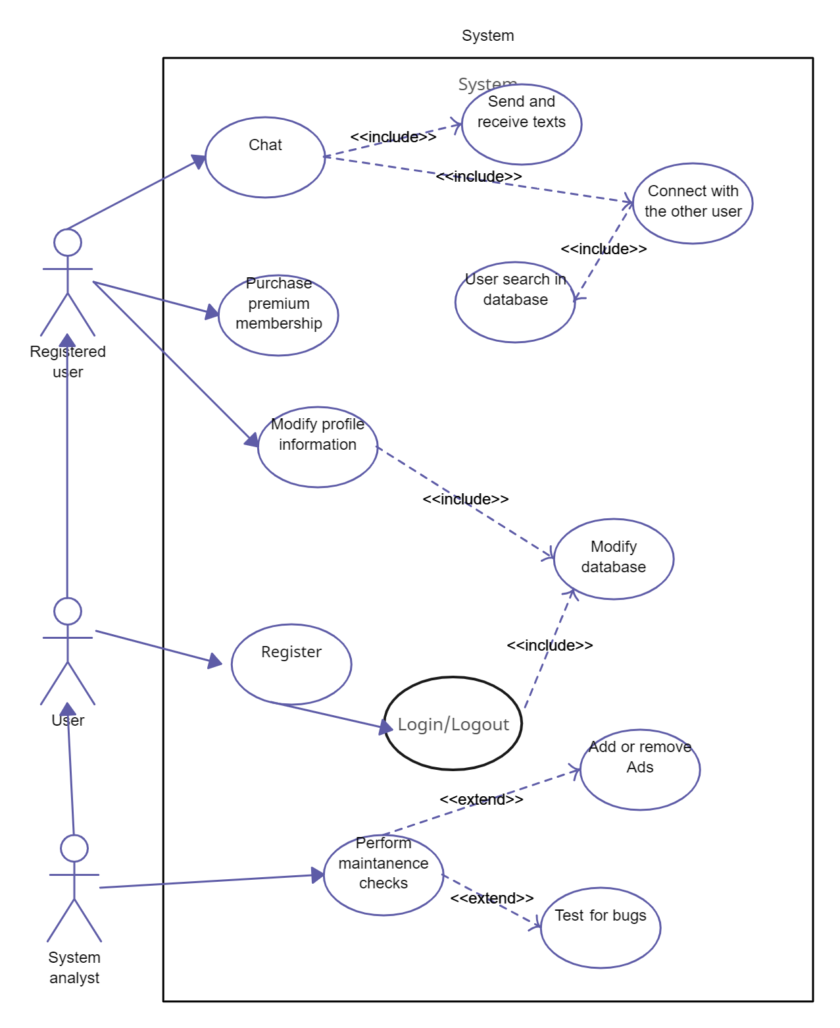Figure 6.1.(i)
6.2 ER DIAGRAM

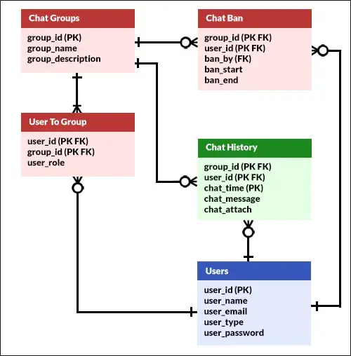
- Figure 6.2.(i)

6.3 DATAFLOW DIAGRAM

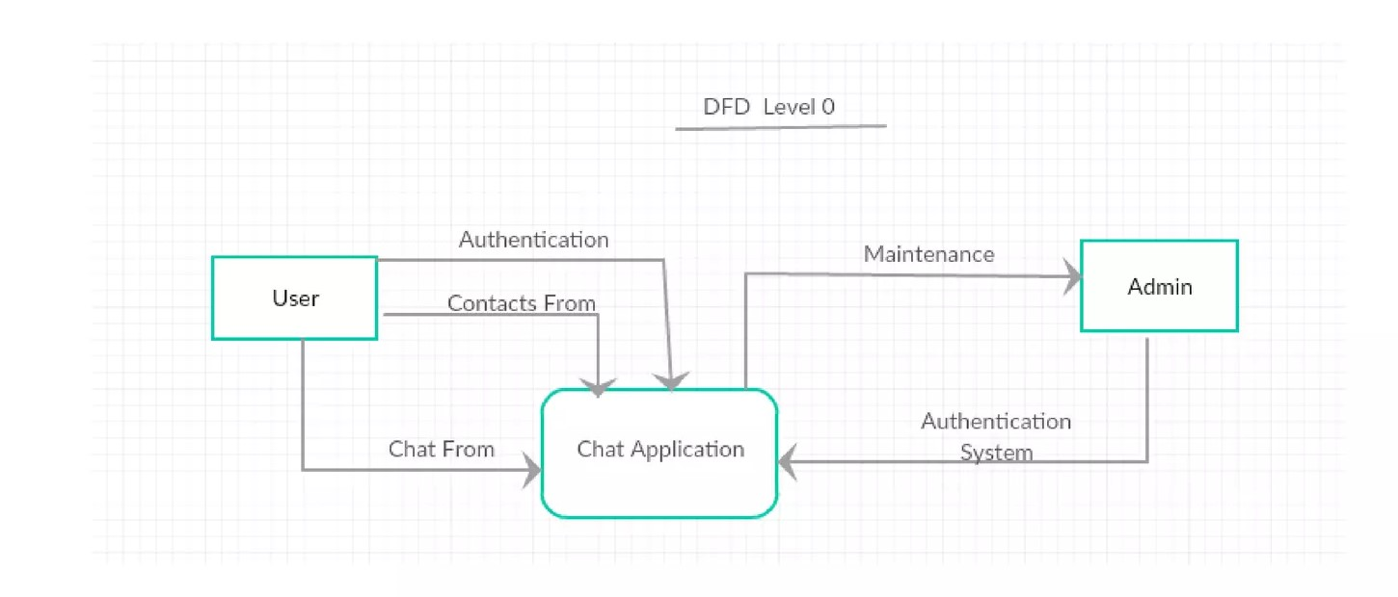
- Figure 6.3.(i)

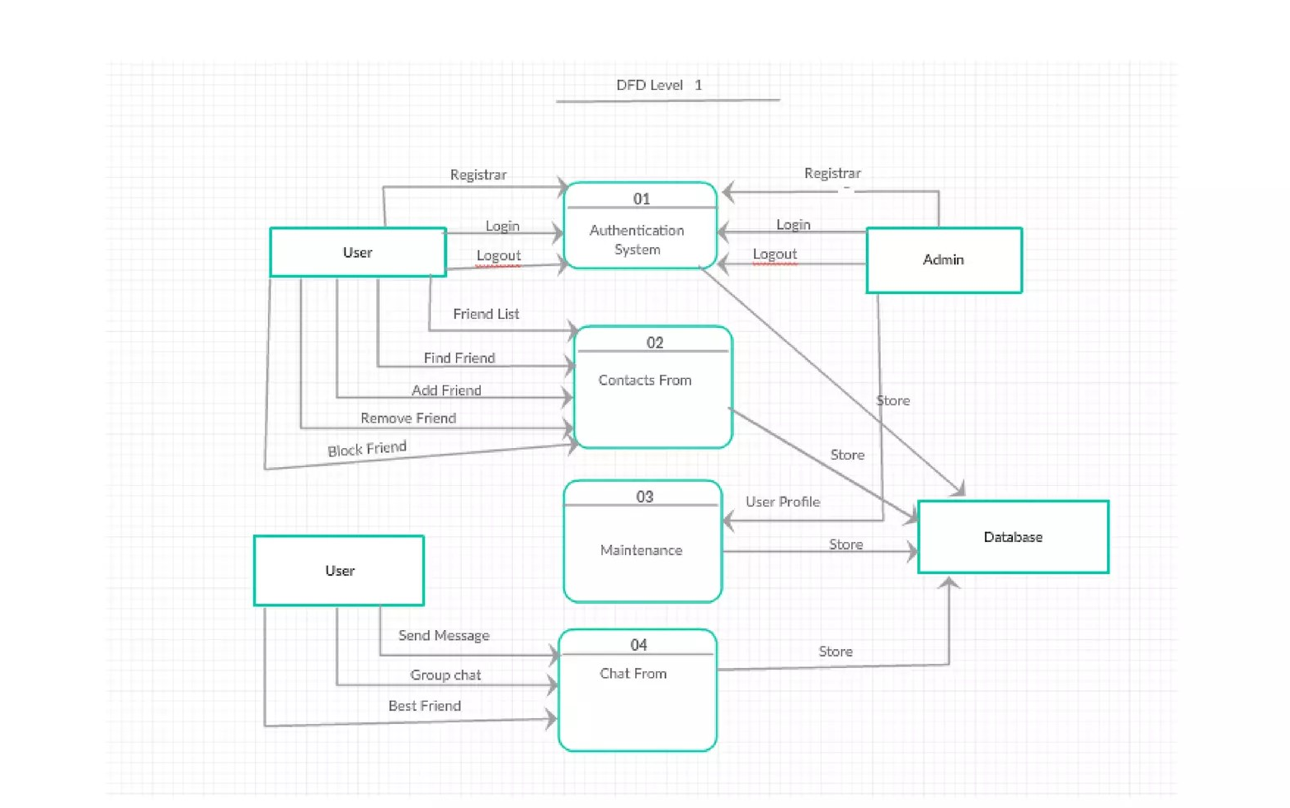
- Figure 6.3.(ii)
CHAPTER 7. IMPLEMENTATION
7.1 SNAPSHOT
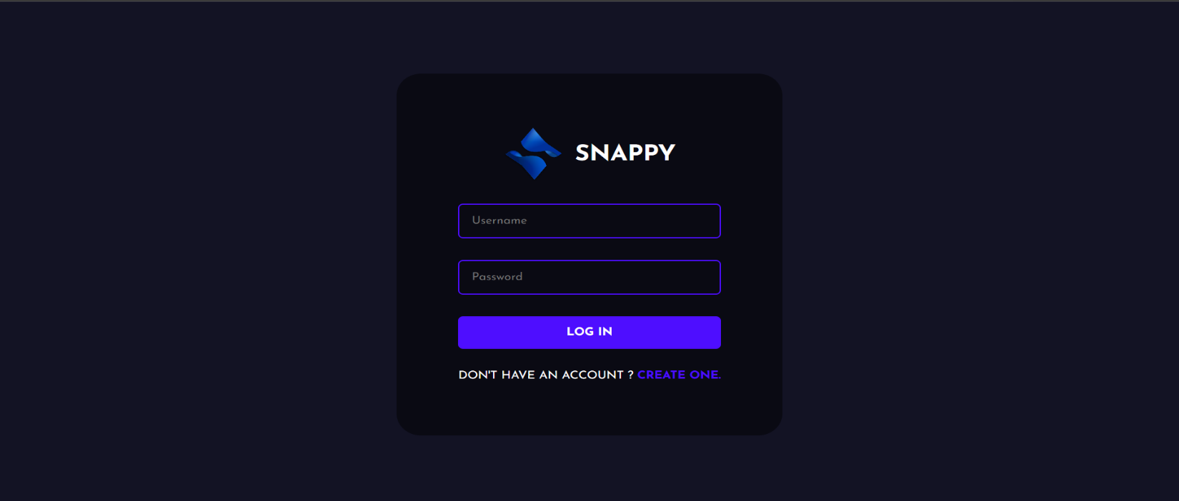
- Figure 7.1.(i)
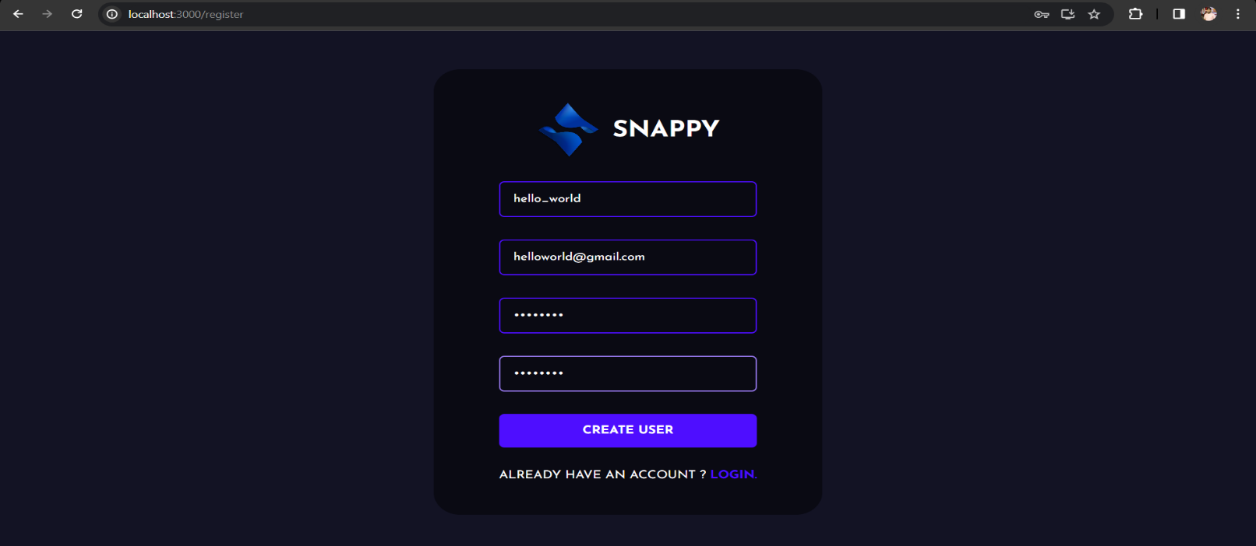
- Figure 7.1.(ii)

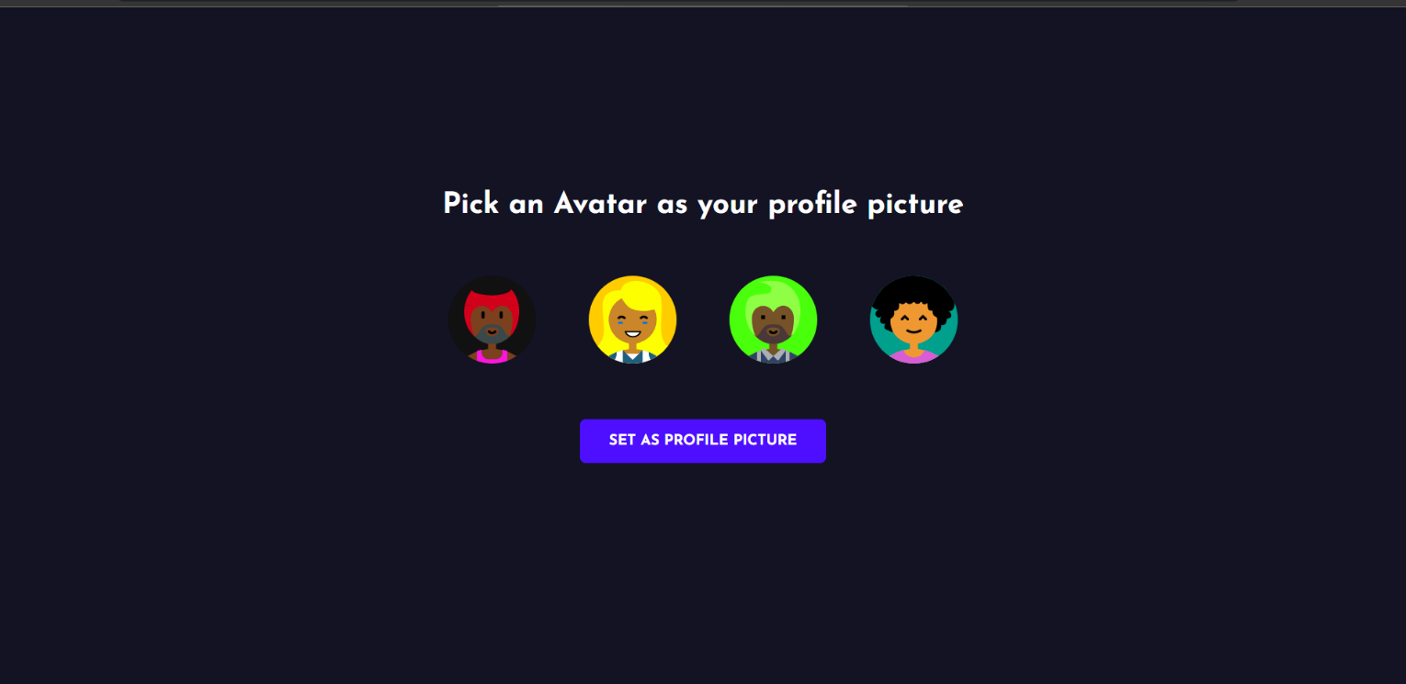
- Figure 7.1.(iii)

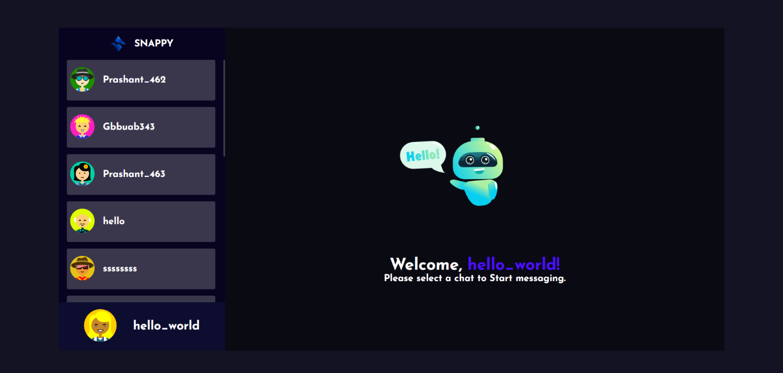
- Figure 7.1.(iv)
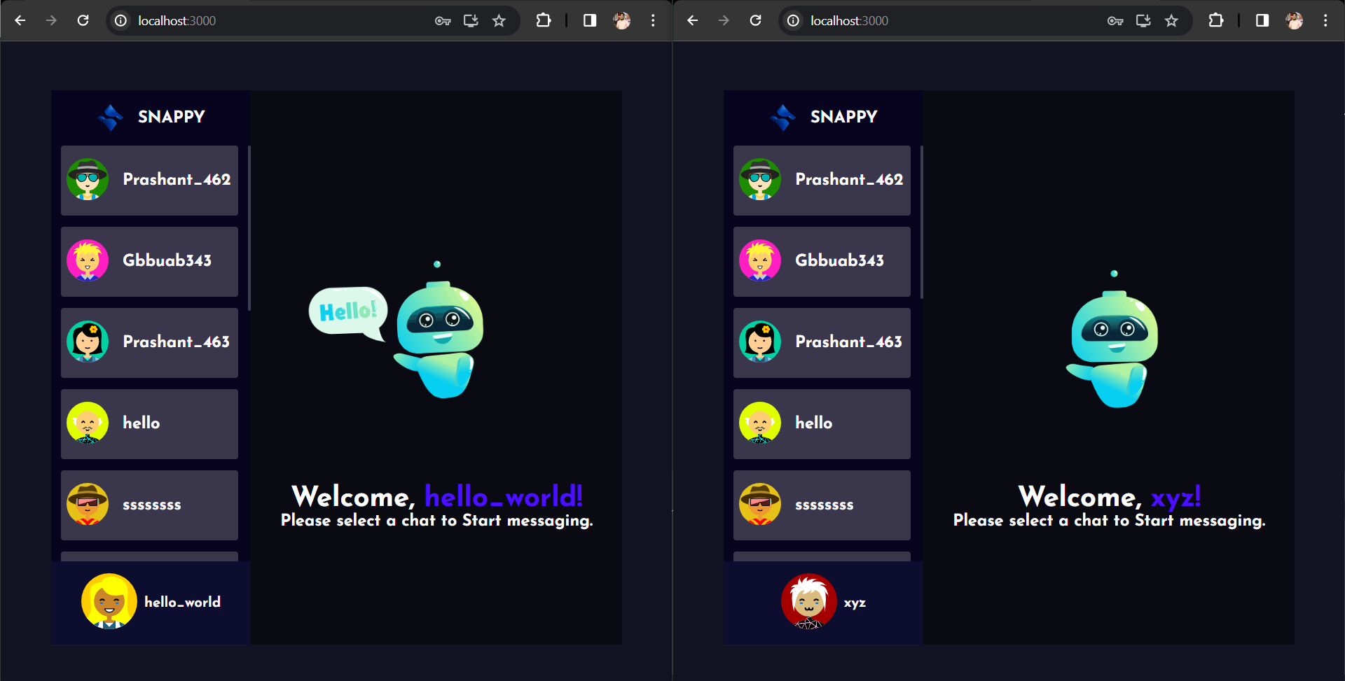
- Figure 7.1(v)
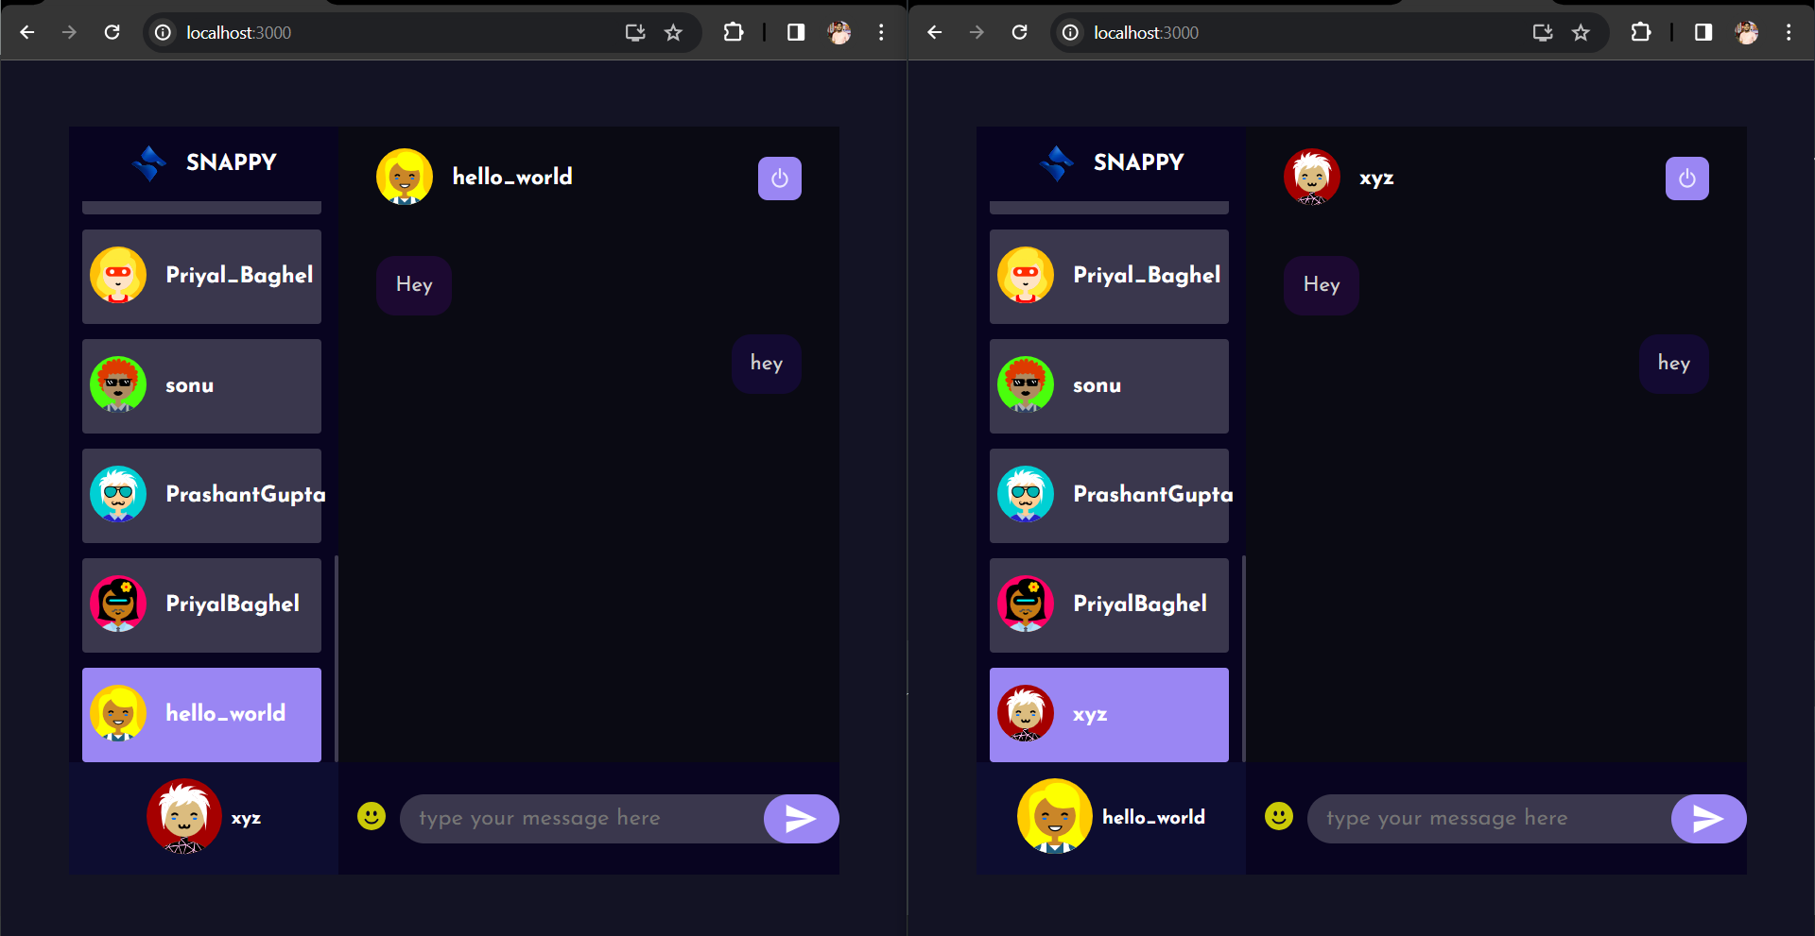

- Figure 7.1(vi)

6.2 CODING
FileName – package-lock.json :
{
"name": "chat-app-react-nodejs",
"lockfileVersion": 3,
"requires": true,
"packages": {
"": {
"dependencies": {
"mongoose": "^7.6.0"
}
},
"node_modules/@mongodb-js/saslprep": {
"version": "1.1.0",
"resolved": "https://registry.npmjs.org/@mongodb-js/saslprep/-/saslprep-1.1.0.tgz",
"integrity": "sha512-Xfijy7HvfzzqiOAhAepF4SGN5e9leLkMvg/OPOF97XemjfVCYN/oWa75wnkc6mltMSTwY+XlbhWgUOJmkFspSw==",
"optional": true,
"dependencies": {
"sparse-bitfield": "^3.0.3"
}
},
"node_modules/@types/node": {
"version": "20.8.3",
"resolved": "https://registry.npmjs.org/@types/node/-/node-20.8.3.tgz",
"integrity": "sha512-jxiZQFpb+NlH5kjW49vXxvxTjeeqlbsnTAdBTKpzEdPs9itay7MscYXz3Fo9VYFEsfQ6LJFitHad3faerLAjCw=="
},
"node_modules/@types/webidl-conversions": {
"version": "7.0.1",
"resolved": "https://registry.npmjs.org/@types/webidl-conversions/-/webidl-conversions-7.0.1.tgz",
"integrity": "sha512-8hKOnOan+Uu+NgMaCouhg3cT9x5fFZ92Jwf+uDLXLu/MFRbXxlWwGeQY7KVHkeSft6RvY+tdxklUBuyY9eIEKg=="
},
"node_modules/@types/whatwg-url": {
"version": "8.2.2",
"resolved": "https://registry.npmjs.org/@types/whatwg-url/-/whatwg-url-8.2.2.tgz",
"integrity": "sha512-FtQu10RWgn3D9U4aazdwIE2yzphmTJREDqNdODHrbrZmmMqI0vMheC/6NE/J1Yveaj8H+ela+YwWTjq5PGmuhA==",
"dependencies": {
"@types/node": "*",
"@types/webidl-conversions": "*"
}
},
"node_modules/bson": {
"version": "5.5.0",
"resolved": "https://registry.npmjs.org/bson/-/bson-5.5.0.tgz",
"integrity": "sha512-B+QB4YmDx9RStKv8LLSl/aVIEV3nYJc3cJNNTK2Cd1TL+7P+cNpw9mAPeCgc5K+j01Dv6sxUzcITXDx7ZU3F0w==",
"engines": {
"node": ">=14.20.1"
}
},
"node_modules/debug": {
"version": "4.3.4",
"resolved": "https://registry.npmjs.org/debug/-/debug-4.3.4.tgz",
"integrity": "sha512-PRWFHuSU3eDtQJPvnNY7Jcket1j0t5OuOsFzPPzsekD52Zl8qUfFIPEiswXqIvHWGVHOgX+7G/vCNNhehwxfkQ==",
"dependencies": {
"ms": "2.1.2"
},
"engines": {
"node": ">=6.0"
},
"peerDependenciesMeta": {
"supports-color": {
"optional": true
}
}
},
"node_modules/debug/node_modules/ms": {
"version": "2.1.2",
"resolved": "https://registry.npmjs.org/ms/-/ms-2.1.2.tgz",
"integrity": "sha512-sGkPx+VjMtmA6MX27oA4FBFELFCZZ4S4XqeGOXCv68tT+jb3vk/RyaKWP0PTKyWtmLSM0b+adUTEvbs1PEaH2w=="
},
"node_modules/ip": {
"version": "2.0.0",
"resolved": "https://registry.npmjs.org/ip/-/ip-2.0.0.tgz",
"integrity": "sha512-WKa+XuLG1A1R0UWhl2+1XQSi+fZWMsYKffMZTTYsiZaUD8k2yDAj5atimTUD2TZkyCkNEeYE5NhFZmupOGtjYQ=="
},
"node_modules/kareem": {
"version": "2.5.1",
"resolved": "https://registry.npmjs.org/kareem/-/kareem-2.5.1.tgz",
"integrity": "sha512-7jFxRVm+jD+rkq3kY0iZDJfsO2/t4BBPeEb2qKn2lR/9KhuksYk5hxzfRYWMPV8P/x2d0kHD306YyWLzjjH+uA==",
"engines": {
"node": ">=12.0.0"
}
},
"node_modules/memory-pager": {
"version": "1.5.0",
"resolved": "https://registry.npmjs.org/memory-pager/-/memory-pager-1.5.0.tgz",
"integrity": "sha512-ZS4Bp4r/Zoeq6+NLJpP+0Zzm0pR8whtGPf1XExKLJBAczGMnSi3It14OiNCStjQjM6NU1okjQGSxgEZN8eBYKg==",
"optional": true
},
"node_modules/mongodb": {
"version": "5.9.0",
"resolved": "https://registry.npmjs.org/mongodb/-/mongodb-5.9.0.tgz",
"integrity": "sha512-g+GCMHN1CoRUA+wb1Agv0TI4YTSiWr42B5ulkiAfLLHitGK1R+PkSAf3Lr5rPZwi/3F04LiaZEW0Kxro9Fi2TA==",
"dependencies": {
"bson": "^5.5.0",
"mongodb-connection-string-url": "^2.6.0",
"socks": "^2.7.1"
},
"engines": {
"node": ">=14.20.1"
},
"optionalDependencies": {
"@mongodb-js/saslprep": "^1.1.0"
},
"peerDependencies": {
"@aws-sdk/credential-providers": "^3.188.0",
"@mongodb-js/zstd": "^1.0.0",
"kerberos": "^1.0.0 || ^2.0.0",
"mongodb-client-encryption": ">=2.3.0 <3",
"snappy": "^7.2.2"
},
"peerDependenciesMeta": {
"@aws-sdk/credential-providers": {
"optional": true
},
"@mongodb-js/zstd": {
"optional": true
},
"kerberos": {
"optional": true
},
"mongodb-client-encryption": {
"optional": true
},
"snappy": {
"optional": true
}
}
},
"node_modules/mongodb-connection-string-url": {
"version": "2.6.0",
"resolved": "https://registry.npmjs.org/mongodb-connection-string-url/-/mongodb-connection-string-url-2.6.0.tgz",
"integrity": "sha512-WvTZlI9ab0QYtTYnuMLgobULWhokRjtC7db9LtcVfJ+Hsnyr5eo6ZtNAt3Ly24XZScGMelOcGtm7lSn0332tPQ==",
"dependencies": {
"@types/whatwg-url": "^8.2.1",
"whatwg-url": "^11.0.0"
}
},
"engines": {
"node": ">=12"
}
}
}
}

FileName - package.json :
{
"dependencies": {
"mongoose": "^7.6.0"
}
}
FileName – index.html :
<!DOCTYPE html>
<html lang="en">
<head>
<meta charset="utf-8" />
<link rel="icon" href="%PUBLIC_URL%/favicon.ico" />
<meta name="viewport" content="width=device-width, initial-scale=1" />
<meta name="theme-color" content="#000000" />
<meta
name="description"
content="Web site created using create-react-app"
/>
<link rel="apple-touch-icon" href="%PUBLIC_URL%/logo192.png" />

<link rel="manifest" href="%PUBLIC_URL%/manifest.json" />

<title>React App</title>
</head>
<body>
<noscript>You need to enable JavaScript to run this app.</noscript>
<div id="root"></div>
<!--

Index.css :
@import url("https://fonts.googleapis.com/css2?family=Josefin+Sans:ital,wght@0,100;0,200;0,300;0,400;0,500;0,600;0,700;1,100;1,200;1,300;1,400;1,500;1,600;1,700&display=swap");

* {
margin: 0;
padding: 0;
box-sizing: border-box;
}

body,
button,
input {
font-family: "Josefin Sans", sans-serif;
}

body {
max-height: 100vh;
max-width: 100vw;
overflow: hidden;
}
.Toastify__toast-theme--dark {
background-color: #00000076 !important;
}
Index.js :
import React from "react";
import ReactDOM from "react-dom";
import App from "./App";
import "./index.css";
ReactDOM.render(
<React.StrictMode>
<App />
</React.StrictMode>,
document.getElementById("root")
);

CHAPTER 8
TESTING
8.1 TESTING
1. Introduction :
The testing phase is a crucial step in ensuring the reliability, security, and performance of Heal Talk: an emotion-based AI chatbot. This chapter presents a detailed overview of the testing strategies, methodologies, and results applied throughout the chatbot’s development process.
2. Testing Objectives:
The main objectives of the testing phase were to validate the functionality, emotion recognition accuracy, security, and performance of Heal Talk. Through systematic testing, we aimed to detect and resolve potential issues, ensuring a smooth, secure, and emotionally intelligent user experience.
3. Testing Types :
3.1 Unit Testing:
Unit testing was performed to validate individual components, functions, and modules in isolation. The Jest testing framework was employed for its robust capabilities in creating and executing unit tests, ensuring the correctness and reliability of each module, including the emotion detection engine and chatbot response system.
3.2 Integration Testing:
Integration testing focused on verifying the interactions between different modules and components of Heal Talk. The Mocha testing framework facilitated the creation and execution of comprehensive integration tests, ensuring smooth collaboration between emotion analysis, response generation, and real-time chat functionalities.
4. Testing Tools and Frameworks :
The following tools and frameworks were used during the testing phase:
- Unit Testing: Jest
- Integration Testing: Mocha
- Automated Testing: Cypress
- Performance Testing: Apache JMeter
- Security Testing: OWASP ZAP
5. Test Cases and Scenarios :
A diverse set of test cases and scenarios were designed to cover multiple aspects of Heal Talk, including:
- Positive and negative test cases for user interactions and chatbot responses.
- Boundary tests to assess system limitations.
- Edge cases to evaluate the chatbot’s behavior in uncommon or complex emotional scenarios.
6. Manual Testing :
Manual testing was employed to assess user experience aspects that are challenging to automate, such as:
- Usability testing to evaluate the chatbot interface and conversational flow.
- Exploratory testing to identify unforeseen issues and enhance user interactions, particularly with emotion recognition and response appropriateness.
7. Automated Testing :
Automated testing was integrated into the development workflow using Cypress. Continuous testing with each code commit allowed early detection of issues, ensuring a seamless development process and consistent chatbot performance.
8. Performance Testing :
Performance testing was conducted using Apache JMeter to assess the scalability and responsiveness of Heal Talk. Key aspects included:
- Load testing to evaluate chatbot response times under varying user activity levels.
- Stress testing to identify the application’s breaking point and ensure reliable operation during peak usage.
9. Security Testing :
Security testing measures were implemented to safeguard user data and privacy. OWASP ZAP was used to:
- Identify and mitigate potential vulnerabilities in data handling and authentication.
- Test encryption and secure authentication mechanisms.
10. User Acceptance Testing (UAT) :
User acceptance testing involved end-users interacting with Heal Talk in a real-world environment. Valuable feedback led to improvements in:
- User interface design for smoother conversation flow.
- Feature usability and accessibility, especially for emotion-based interactions.
11. Results and Findings :
The testing phase revealed a total of [number] issues, including:
- [Brief description of major issues identified, e.g., inaccurate emotion detection or delayed response times.]
- [Details of how each issue was addressed, e.g., algorithm adjustments, performance optimization.]
These issues were promptly addressed, resulting in a more robust and reliable AI chatbot capable of emotionally intelligent interactions.
12. Challenges and Lessons Learned :
Challenges faced during testing included:
- Handling ambiguous or mixed emotional inputs.
- Ensuring performance stability under heavy simultaneous user interactions.
- Integrating continuous feedback to improve response accuracy.
13. Conclusion :
The testing efforts significantly enhanced the reliability, performance, and user experience of Heal Talk. Rigorous testing methodologies, automation, and continuous feedback loops were critical in delivering a high-quality, emotion-aware AI chatbot.
14. Recommendations for Future Testing:
For future iterations, it is recommended to:
- Expand testing scenarios to include more complex emotional states and multi-turn conversations.
- Maintain a continuous focus on security to adapt to evolving threats.
- Broaden performance testing to accommodate increased user load and scalability requirements.

CHAPTER 9
CONCLUSION & FUTURE SCOPE
9. CONCLUSION & FUTURE SCOPE
The development and implementation of Heal Talk: an emotion-based AI chatbot mark the successful realization of an intelligent, user-centric conversational platform. Through meticulous design, development, and testing phases, the project has delivered a robust and feature-rich chatbot capable of understanding and responding to users’ emotions while providing a seamless, interactive experience.
Future Scope :
While Heal Talk has achieved significant milestones, there are several opportunities for future development and enhancements:
1. Feature Expansion
- Enhanced Emotional Intelligence: Improve the chatbot’s ability to detect and respond to nuanced emotional states, including mixed or subtle emotions.
- Multimedia Messaging: Integrate support for sharing images, voice notes, videos, and documents to enrich conversations.
- Group Conversations: Enable group chat functionality for multiple users to interact simultaneously.
- Voice and Video Interactions: Explore voice and video chat features to make interactions more engaging and human-like.
2. Platform Diversification
- Mobile Applications: Develop dedicated iOS and Android apps to expand accessibility and reach a wider audience.
- Desktop Applications: Create desktop versions for Windows, macOS, and Linux to facilitate broader usability.
3. Advanced Security Measures
- Two-Factor Authentication (2FA): Add extra layers of security to protect user accounts and sensitive data.
- Regular Security Audits: Conduct periodic security evaluations to proactively identify and address vulnerabilities.
4. Integration with External Services
- Cloud Storage Integration: Allow users to share files directly from popular cloud storage services for convenience.
- Social Media Connectivity: Enable users to connect with social media platforms to share insights or chatbot-generated recommendations.
5. AI-Powered Features
- Smart Notifications: Implement AI-driven notifications that prioritize messages based on user behavior and emotional context.
- Automated Moderation: Utilize AI algorithms to moderate content, ensuring respectful and safe interactions within the platform.
- Emotion-Based Recommendations: Enhance user engagement with personalized suggestions and coping strategies based on detected emotional states.

CHAPTER 10
REFERENCES

REFERENCES :
- Author, A. (Year). Research on Emotion-Based AI Systems and Chatbots. Journal/Publisher. [Link]
- Technology Documentation. (Year). Technologies Used in Heal Talk (AI, NLP, ML Models, Web Technologies). [Link]
- Smith, J. (Year). Article on Emotional Intelligence in AI Chatbots. Magazine/Website. [Link]
- Jest Testing Framework Documentation. (Year). Jest — JavaScript Testing. [Link]
- Mocha Testing Framework Documentation. (Year). Mocha — JavaScript Test Framework. [Link]
- Cypress Testing Framework Documentation. (Year). Cypress End-to-End Testing. [Link]
- Apache JMeter Documentation. (Year). Performance Testing for Web Applications. [Link]
- OWASP ZAP Documentation. (Year). Security Testing for Heal Talk. [Link]
- Selected Testing Tools Documentation (e.g., JMeter, OWASP ZAP). (Year). Tools for Performance & Security Testing. [Link]
- MongoDB Documentation. (Year). NoSQL Database Used in Heal Talk. [Link]
- Firebase Documentation. (Year). Firebase Authentication & Real-Time Database. [Link]
- Git Documentation. (Year). Version Control for Heal Talk development. [Link]
- Project Management Tools (Jira, Trello). Documentation for Task & Workflow Management. [Link]
- Real-Time Communication Protocol Documentation (WebSocket). Used for live chatbot response handling. [Link]
- Online Learning Resources (Coursera, Udacity). Courses related to AI, NLP, and chatbot development. [Link]
- Case Studies on Emotion-Based AI Chatbots. Documentation/examples used for feature inspiration. [Link]

*******************************************************************



LAKSHMI NARAIN COLLEGE OF TECHNOLOGY EXCELLENCE, BHOPAL

PROJECT COMPLETION PLAN

- Project: Major/Minor : Minor Group NO: 48
- Name of Students : 1) Sakshat Shrivatra
2) Pranjal Chansauriya
3) Yash Raj Vishwakarma
4) Rakesh Kumar

- Branch : Computer Science Semester: 5th

- Guide’s Name : Miss Muskan Shrivastava

- Project Title : Emotion based ai chatbot

- Tools Required : Vs Code , Github, Git,

    - Starting Date : Nov 2022 || Expected Date of Completion: Jan 2023

PROGRESS
Monthly | Details of Works Carried out | Guide’s Signature with Date | HOD’s Signature with Date | Remarks by HOD/Guide
JULY’23 | Requirements & design
AUGUST’23 | Implementation, coding(frontend & backend)
SEPTEMBER’23 | Testing
NOVEMBER’23 | Final submission & presentation

    - Date of Submission : 17 Nov 2023
    - Date of Presentation : ……………………………………………..
    - Approved/Not Approve : ……………………………………………..
    - Signature :

Students Guide HOD
(1) Prashant Gupta ___________________________ ________________
(2) Priyal Baghel ___________________________ ________________
(3) Namrata Garve ___________________________ ________________

